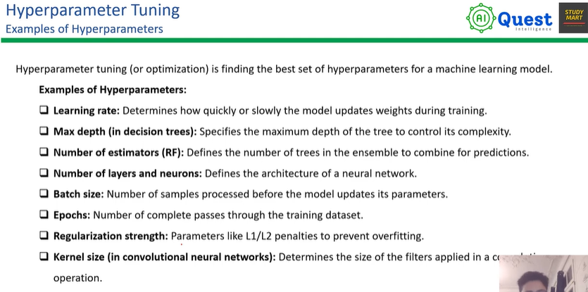

Example:

SVM

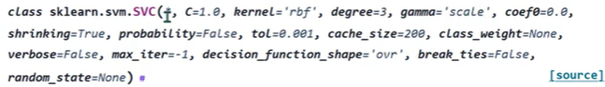

We must know how an algorithm works for tuning hyper parameter.

Approach of tuning hyper parameter:

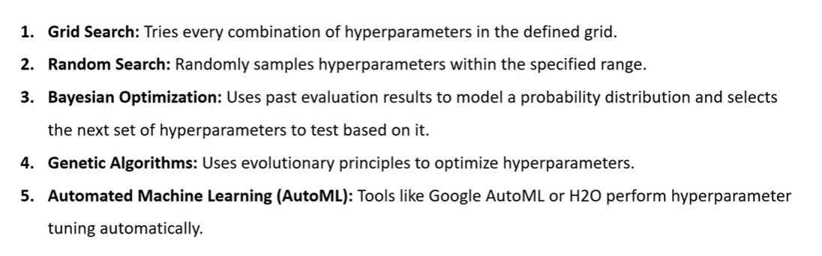

For small data set – Random search is good

For big data set – Grid search and Bayesian optimization are good.

Feature Selection technique:

